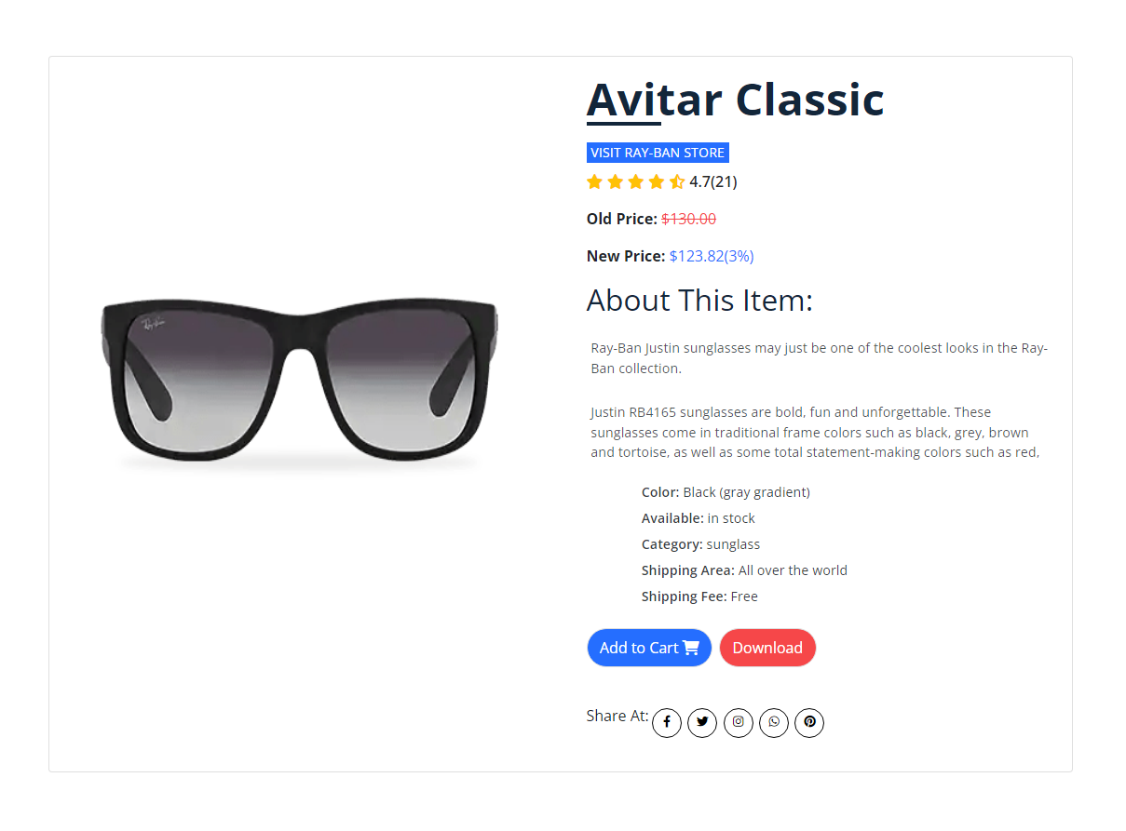
Product Details
Currently one of the most iconic sunglass models in the world, Ray-Ban Aviator Classic sunglasses were originally designed for U.S. aviators in 1937. Aviator Classic sunglasses are a timeless model that combines great aviator styling with exceptional quality, performance and comfort.
With a classic gold frame, you can see the world through a variety of lens colors including crystal brown, crystal green, G-15 polarized and more that provide optimum visual clarity and 100% UV protection.

